## ABOUT ME

#### I am competent computer networks and IT. and cyber security trainee. I am interested in entrepreneurship and creativity. I had many trainings in entrepreneurship and project management to help me establish my own business.

EDUCATION

Diaa Azzam Ihraiz

Palestine Polytechnic University

Sep 2012 - Jun 2014

# COMPUTER

NETWORKS & INTERNET

Diploma degree in computer and internet networks, 80.5%. Shamel exam, good degree.

#### Hebron Industrial Secondary School

Sep 2010 - Jun 2012

+972568888130

Hebron, Palestine

Secondary school, Computer maintenance, 70.8%

WORK EXPERIENCE

### [Diaa.s@outlook.sa](mailto:Diaa.s@outlook.sa) DiaaAIhraiz

LANGUAGE

#### Noman Al-Juneidi Food Industries.

Orcas Technologies Ltd.

Herbawi Industrial Trading Co.

Technology Center.

Jan 2019 - Until Now

Jan 2018 - Apr 2019

Jan 2015 - June 2017

Feb 2013 - Mar 2017

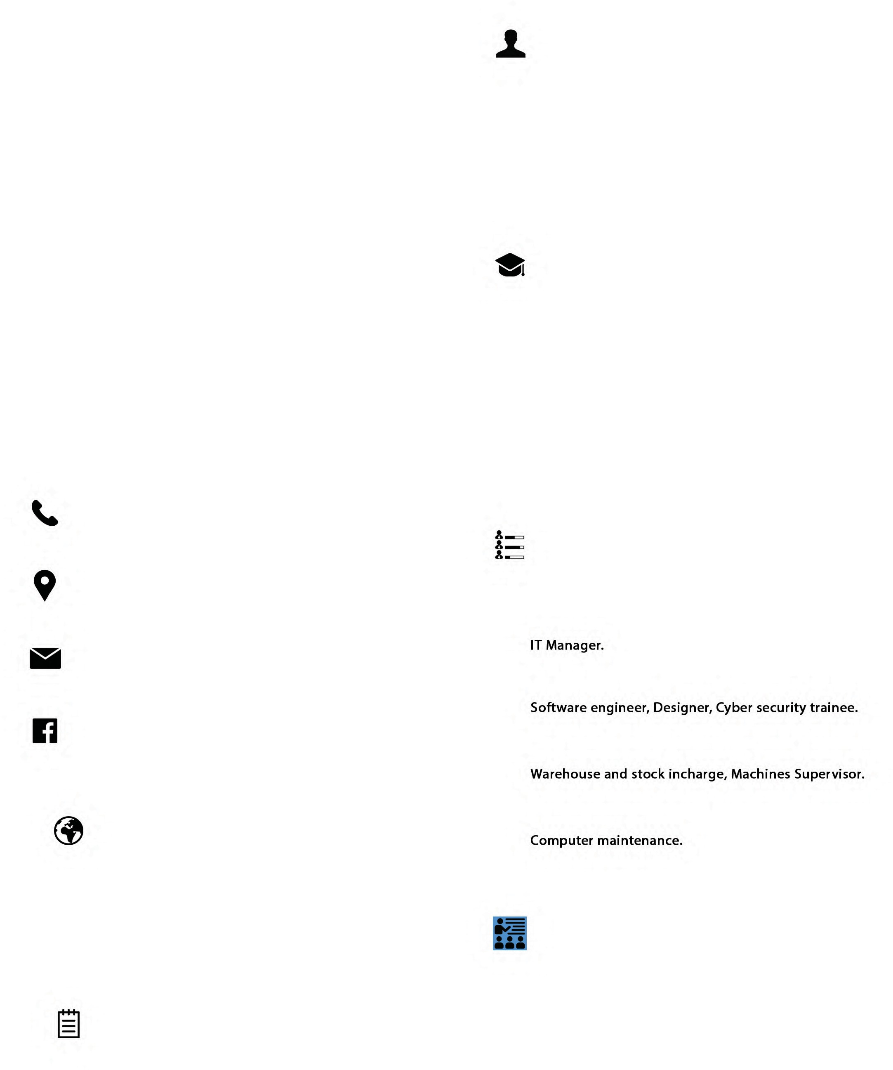

ARABIC ENGLISH

SKILLS

 LEADERSHIP TEAMWORK

 DECISION MAKING  TIME MANAGEMENT  CREATIVITY

 PHOTOGRAPHY

 WORK UNDER PRESSURE

TRAINING

#### Bethlehem Business Incubator - BBI

* Marketing
* Branding- General
* Branding- Mission, Vision and logo
* Market Research
* Business Plan Development
* Facebook Ads Basics
* Presentation & Pitching Skills
* Financials
* Taxes in Palestine
* Strategic Management
* Customer Services
* Business Writing Communications Skills
* Management
* IT session- Website Development

Aug 2017 - Aug 2019